Duke University

Track and Field
Finding the Right Track for Pro-Athletes
by
Calvin Won Park

18 November 2014
Game Theory and Democracy
Track and field is one of the oldest of sports. Athletic contests were often held with religious festivals, as with the Olympic Games of ancient Greece. Since 776 B.C, for 11 centuries, athletic contests were for men only and were very popular and prestigious. These Games were continues by Romans until Emperor Theodosius I in A.D 394 banned the Games. During the Middle Ages organized track and field games were all but vanished. It was not until 19th century that true modern form of track and field sport was developed. This sport was motivated by English public school and university students’ interclass meets, or meetings as they are still called in Britain. In 1849 the Royal Military Academy at Sandhurst held the first organized the modern form of track and field meet.
However, the sport did not flourish until the 1860s. In 1866 the newly formed Amateur Athletic Club, which opened the competition to all “gentlemen amateurs” specifically, held the first English championships athletes who received no financial compensation for their efforts. This standard has lasted to the present day and is the basis of the amateurism of this sport. Amateur Athletic Association in 1880 conducted the annual national championships since that the Amateur Athletic Club gave way to the association. Track and field started gaining popularity in the late 1860s, after the formation of the New York Athletic Club in 1868,even though meets were held on the North America early as 1839. In 887, The Amateur Athletic Union of the United States (AAU), an association of track and field clubs, was formed and has governed the sport in the United States until nowadays.
In 1896 the first modern Olympic Games were held. Although initially with the limitation, the Olympics captured the imagination of athletes and steadily grew, making track and field an international sport for the first time. In 1913, representatives from 16 countries formed the International Amateur Athletic Federation (IAAF). The IAAF was establishes standard rules for the sport, approves world records, and ensures that the amateur code adheres. These standards are still being carried out.
The participation of women in track and field is a relatively recent. In 1921, an athletic federation for women was form by representatives from six countries which merged with the IAAF in 1936. Participation by women has grown rapidly in many countries in recent years, particularly in the United States.
However, even with the sport having the oldest sports history and basis of every sport, living as a pro track and field athlete is extremely difficult.
Is track and field really a professional sport?
For Usain Bolt, it is. A Forbes magazine survey estimated the Jamaican sprinter's annual earnings at $23.2 million, ranking 45th on a list of the world's richest athletes.
A world record-holder in a relay, Kind Butler III, The Indianapolis sprinter estimated his 2013 earnings from track: $6,000, about 4,000 times less than Bolt. That underscores a challenge track and field athletes face.
"There's a big gap between the haves and have-nots in track and field," said Merhawi Keflezghi, a Fishers agent who represents his brother, Meb Keflezghi, a 2004 Olympic silver medalist and winner of April's Boston Marathon. Haves within track and field are very limited and rarely achievable by pro athletes.
To increase earnings, the sport must be elevated in popularity and presentation. Georgia agent Paul Doyle to introduce the American Track League, a series of meets that made their debut May 2 in Bloomington to promote track and field to public. The meet featured a compressed program, live music and athlete interaction with fans. This event was one of the first ever track and field event where track and field came out of its prestigious norm and stepped up to approach to the fans.
"It's so hard to be a track fan in America because there's so little exposure," Doyle said. "You have to be passionate to be a true fan of track. All those other sports, you're slapped in the face with it every day."
In current media world where 24-hour sports channels and a need for live programming, track has enough source for it. The USA Championships was held on June 26th through 29th in Sacramento, Calif., and NBC, NBC Sports Network and Universal Sports shared TV coverage. NBC has a deal with USATF for exclusive rights to its events.
However, that won't cover all major meets because so many channels cover track and field meets.
It is difficult to identify track incomes because most of it is derived from shoe sponsorships, the amounts of which athletes generally do not reveal. Contracts also include bonus incentives. For example, when Asthon Eaton, decathlete, set a new world record at 2012 USA Track and Field Olympic Trials, he received $750,000 from Nike.
But separate surveys taken by the Track & Field Athletes Association, a labor union, and the USATF Foundation came to the same conclusions: More than 50 percent of those ranked in the world's top 10 earn less than $15,000 from their sport, and there are wide variations between events. Comparing to the NBA, 10th player on the salary list earns $19,317,326.

There probably aren't 10 American track athletes who earn more than the NBA minimum: $490,000. This numbers makes some people wonder if track and field is a pro sport at all. However, track and field has been openly a pro sport since the 1980s.
Nike’s monopoly
Athletes with winning medals or competing on the international Diamond League are full-time athletes. Andrew Poore, 25, finished fourth in the steeplechase at last year's nationals, one spot from the World Championships, retired from track because of lacking of financial support. He had earnings of $5,000 in 2013 even though he was number 4 in the nation.
"If I'm not a professional athlete, I'm not going to waste my time trying to pretend like I'm something I'm not," said Poore, who recently was promoted to full-time assistant at IU after serving as a volunteer coach.
Because many athletes cannot afford to devote the time, Poore said, "most of the people in my position are not doing it to the best of their abilities. They're doing it because they're not comfortable giving it up. But what they don't realize is they're not going to get better."
Nike is unquestionably the sport's biggest sponsor which creates both positive and negative effect. Former shot putter Adam Nelson, president of the athletes' union, said that without Nike, "I'm not sure there's a sport."
USATF recently extended its sponsorship with Nike of through 2040, reportedly worth $500 million. This is about double the amount what had been sponsored to USATF, which already gets about half of its $19 million budget from the Nike. Letsrun.com published an April Fool's Day spoof announcing USATF had become a subdivision of Nike.
Max Siegel, CEO of USATF, said he is "perplexed that there is this angst toward the shoe companies".
"I'm careful with it because they'll take my head off because people feel a certain way about it," Siegel said. "But it's interesting that the very bedrock and the foundation of the sport is supported by those shoe companies, who get a bad rap. So I often ask the question, coming in relatively new, ... has anyone ever sat back and asked what this industry would like if the shoe companies divested?"
Many critics have suggested Nike has too much influence and it is not hard to find that it is true. This can be seen from a disproportionate share of championships awarded to Nike's home state, Oregon, to fallout over two dubious disqualifications at the indoor nationals: Alberto Salazar, coach at Nike Oregon Project, was in the middle of one protest that led to a disqualification that was overturned by Siegel.
Many pro athletes attempted to create a separate federation for pro track and field coming out of USATF. This failed to do so since the pros receives nearly 50 percent of the organization's funding.
Athletes would like to expand sponsorship beyond shoe companies, but there are restrictions on what logos they may wear, especially in weeks before the Olympics. USATF has lifted those restrictions, but the International Olympic Committee has not. Nick Symmonds, two time Olympian, said “You don’t see Ford saying you can’t put another sticker on the car” he says, highlighting track and field’s governing body’s issue over athlete sponsors potentially clashing with event sponsors. “They understand that by growing the pie, it’s only going to help the whole sport.”
At the Olympic Trials, Nick Symmonds, two-time Olympian and US top 800m runner, had a small strip of white athletic tape on his left shoulder. The tape is covering up the logo and Twitter handle of one of his sponsors, Hanson Dodge Creative, a company that bought the sponsorship rights to Symmonds’ shoulder on eBay for more than $11,000.
Symmonds said, “I wear a Hanson Dodge Creative temporary tattoo on my left shoulder in every single competition, unfortunately due to the rules [for certain meets], I’m not allowed to display it anywhere in the media zone or the competition area.”
Symmonds is fighting a similar struggle that was fought nearly 40 years ago by the Pre Classic’s, Steve Prefontaine. The legendary Oregon runner was one of the top distance runners in the world, However during the early 1970s he had to live a very insufficient life because the rules of the time that didn’t allow track and field athletes to earn prize money from races or any sponsors if they wanted to compete at the Olympics. Symmonds claims, “As an athlete who wants to see more dollars in track and field, I say let’s stop kicking potential sponsors out of the sport” he said. “There are so many companies out there that want to invest dollars in athletes, let’s let them.” Symmonds with many other athletes are fighting hard to make sure athletes who are struggling financially can have the opportunities he believes are out there.

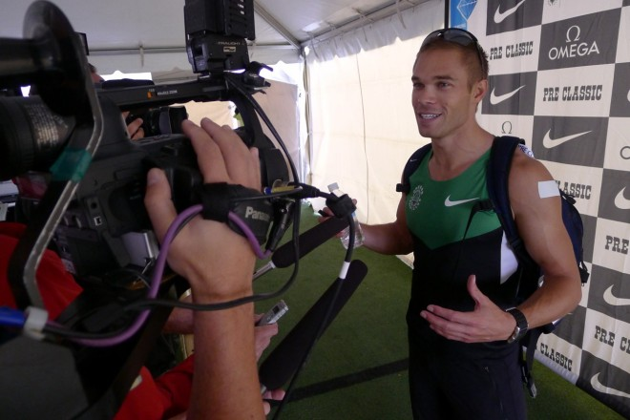
"When we bring up that conversation, it's like Voldemort in 'Harry Potter,' " Nelson said of the IOC. "We can't even mention his name."
As debates rage over the influence that shoe companies play in elite track and field, and athletes strive to secure other forms of sponsorship. A survey by the Track and Field Athletes Association makes clear that without the shoe companies, few of these runners would be making any kind of living at all. Middle-distance and distance runners fare far better in income areas and appearance fees than do throwers and jumpers, and infinitely better than racewalkers, who, according to data in the association’s 2013 Track and Field survey illustrates they are very close to true amateurism.
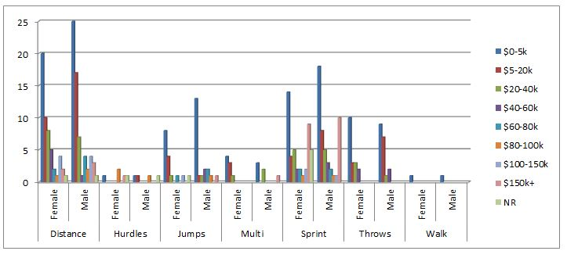
The reality being a professional athlete of the most historical and fundamental sport, track and field, is not glamorous as it sounds like but rather it is hungry. Even being the oldest and bedrock of sport, current situation of track and field is very underprivileged. Track and Field should get as much attention as other major sports and professional track and field athletes should be paid and respected as much as other professional athletes, such as Lebron James and Payton Manning. In order for track and field to grow, there needs to be more media covering track and field events to attract people attention to the sports and track and field meets should come out of its traditional norm and attempt to reach out to the fans and make the meets more enjoyable. For professional track and field athletes to make profits, one company, Nike, should not the monopoly sponsor of a federation or association and an association should not censor one’s sponsorship.

Summary
Track and field is the oldest sport in the athletic history and it is the fundamental sport for almost every sport. Track and field is considered the highlight of the Summer Olympic Games. However behind the glamorous surface, there are many dark sides people do not usually see.
Even being a sport with the deepest history of athletic, not that many people pay close attention to the track and field. One needs to be a big fan, in order to pay any attention to track and field and its athletes. Contrasting to track and field, most of the people know and watch NBA, NFL, or other major sports. More people know who Payton Manning is than Aston Eaton, who is one of the greatest athlete ever and a world record holder in decathlon. Track and Field is overly underprivileged and deserves more attention and respect.
In order for track and field to flourish, more media need to cover track and field events, not just the major ones. Then more people will be exposed to the sport and hopefully interest them. Besides the effort of the media, track and field itself should step out of its traditional norm of being a prestigious sport and reach out to the fans and make the meets more approachable for normal people. Many people, such as Paul Doyle, are attempting to host track meets where it is approachable to everyone and more enjoyable than the traditional track meets.
Besides Usain Bolts and small number world top athletes, even some world top athletes, financial struggle. There probably aren't 10 American track athletes who earn more than the NBA minimum: $490,000. Comparing to the major sports, track and field athletes’ earning is not even comparable. There is no reason track and field athletes should earn less than some of the major sports athletes. Track athletes work as much or even more than major sports athletes.
There is a problem in the USATF, USA Track and Field, association. Being dominantly sponsored by Nike, the association does not allow other sponsorships to appear on its track events, which is majority in USA. There are many companies out there that wish to sponsor track and field athlete but due to the association rule, companies have hard time sponsoring the athletes which does not help the athletes from struggling.
In order for professional track and field athletes to make profits, monopoly of Nike should be banish and association should not be affiliated with any private company as much as it is right now.

Works Cited
Gambaccini, Peter. "For Elite Runners, Economic Struggles and Disparities Persist." Runner's World & Running Times. N.p., 23 July 2013. Web. 10 Nov. 2014.
Germano, Sara. "Nike, Brooks Running Get Entangled in Track Controversy." The Wall Street Journal. Dow Jones & Company, 2 Apr. 2014. Web. 10 Nov. 2014.
Jordan, Tom. "Track and Field | Scholastic.com." Scholastic Teachers. N.p., n.d. Web. 10 Nov. 2014.
Paur, Jason. "Olympic Runner Fights to Change Sponsorship Rules | WIRED." Wired.com. Conde Nast Digital, 25 June 0012. Web. 10 Nov. 2014.
Woods, David. "Pro Track Athletes Make as Little as $5,000." Pro Track Athletes Make as Little as $5,000. N.p., 23 June 2014. Web. 10 Nov. 2014

