KYL
October 5, 2017
Democracy in the Hive Mind
Sheltered by legions of loyal guards in her hanging wax castle, the queen honeybee is nature’s iconic monarch. However, behind this symbolic biological hierarchy, these insects practice a democratic election with a large scale preferential ballot, giving all voters an equal chance to express their opinions. As winter approaches, the hive divides into two clusters: one group relocates to a new home with the previous queen and the other group stays to raise the next generation’s queen. In search of a nesting site, the migratory swarm of bees utilizes group wisdom to maximize their chances of survival by choosing the optimum nesting site for their new home. However, much like human elections, these choices are not always correct. Due to dangerous environmental conditions restricting time, there are inherent weaknesses in the honeybee’s selection methods that can cause a premature decision to be reached, or for equally fit choices to split the hive. Despite these drawbacks, the honeybees display unbiased and open-minded decision making with no ulterior motives, showing a surprising rate of successful elections. Survival is their goal and evolution has deemed their group wisdom to be an invaluable guide. The honeybee’s biological character and social behavior reveal the mechanism behind its near perfect probability of democratically electing the optimum nesting site, and since its only weakness is time, the honeybees have nearly perfected the art of harnessing group wisdom.
Researcher Thomas Seeley conducted a comprehensive analysis of this behavior, and his work is one of the only sources of data for this subject. Others used his data as the foundation of their scientific models, or studied the behavior of similar organisms and made conclusions that applied to all social creatures.
Beginning in the early summer, honeybee colonies begin preparations for swarming - the process of relocating to a new home. First, about a dozen eggs are raised in specially designed queen cup cells at the base of the hive, and the larvae are fed a royal jelly that forces them to develop into queens. Within sixteen days, adult queens emerge from their cells, triggering a change in their mother queen’s physiology. Worker bees feed her less as her egg production rate drops, causing her abdomen to dramatically reduce in size. This weight reduction is further enforced by members of the hive shaking or lightly biting the queen, prompting her to constantly move and burn energy. In total, she has lost close to a fourth of her body weight; this is necessary to allow the normally bloated queen to fly to her new nesting site. Meanwhile, the worker drones lazily rest in the hive, gorging themselves with honey and stimulating their wax glands in preparation for the work ahead. When a scout drone runs through the hive, loudly vibrating her body in a process called piping, these sluggish workers begin warming their flight muscles. Once the group reaches ninety-five degrees Fahrenheit, the swarming process begins, and a mass of ten thousand workers cluster around the queen on a nearby branch to begin the democratic process of choosing their next home.
There are four main properties that honeybees consider when deciding on their hive location: cavity volume, entrance height, entrance size, and abandoned combs. A 40-liter tree cavity provides enough honey storage to last the winter, an entrance high off the ground averts predators such as bears, a small opening is easily defendable, and the presence of abandoned combs by a previous colony is very beneficial in saving energy. Protection from harsh weather is also important, so the direction of the entrance and the wind resistance of the walls are also taken into account. These are essentially the qualities that a candidate location must maximize in order to win a honeybee nesting site election.
To search for these candidates, elder foraging bees adopt their new roles as scouts and disperse into the surrounding environment. After locating a potential site, the scout investigates the suitability of the cavity based on the previously mentioned qualities and returns to the swarm. A dance is performed, with its direction and length representing location, and number of repetition representing the quality of the site. Nearby bees, seeing this dance, then investigate the site and return to the swarm with their own judgment and dance; however, bees that are revisiting old sites slowly lose interest and dance less frequently until they return to a neutral state. Eventually, the group of scouts become a unanimous dancing preference for a single site, and the swarm takes off to its new home. A democratic election through group wisdom has taken place, and miraculously, over ninety percent of the time, the bees have chosen the optimum nesting location.
The first factor that allows for this success is the characteristic of individual honeybees as voters. Since these insects are all naturally programmed to choose the best option for survival, they have congruent interests, and since the same qualities of nesting sites are favored, the bees are considered to show shared preferences. Furthermore, honeybees are incapable of deceit, so their true judgments are displayed for every candidate. Similarly, the candidates are nonliving entities, so their qualities are objectively ranked rather than subjectively decided. This “unitary democracy” of complete honesty is aimed to accurately elect the best option without the drawbacks of human “adversary democracy,” where strong divides must be reconciled before a decision is made. With the common goal of survival, honeybees are naturally compelled to come to a unanimous decision that will elect a candidate only if its qualities truly make it the best choice. By this property, there is no need for a tie breaking vote, where the fate of the whole depends on the opinion of a single individual tipping the balance towards majority. The entire swarm will fully support the elected nesting site
A result of this common goal is that the many wrongs principle takes effect and explains an increase in navigational accuracy. In a large group, all individuals want to navigate to a common target, in this case the best nesting site, but they do so with some error. But as the number of individuals increases, their errors are averaged out. As a result, the error of navigation for the group as a whole decreases.
The voters are also well equipped to make accurate decisions, and Condorcet’s jury theorem helps uncover the mechanism behind their high success rate. First, it must be established that although the decisions are made under uncertainty – individuals only have incomplete and noisy information about the environment- they are still able to elect the best outcome. Since information can only be transmitted through dances, information about the qualities of each and every candidate is incomplete. A bee will not be able to compare every candidate at once, and in fact, only twenty-two percent or fewer of the scouts actually visit more than one site. While this lack of information seems like a fatal weakness in an election, swarm intelligence was found to not require any individual to have complete information for the group to arrive at the best decision.
The theorem states that, given two options, each individual voter is given a probability of choosing the correct option between one half and one. Therefore, the probability of the group choosing correctly is greater than the individual and approaches one as the group size increases. The theorem is not applicable if voters have less than a one half chance of choosing correctly, but honeybees have a solution to this problem. Since only the experienced foragers are able to scout and vote, they are both effective in judging candidate nesting locations and in providing accurate information to the rest of the group. This gives the individual voters a high probability of choosing the best candidate, so with a group of about five hundred bees, the optimum nesting site has a high chance of winning.
However, Condorcet’s jury theorem does not apply when scouts are debating between more than two candidates at once. When there are multiple nesting sites competing, other processes take place that narrow down the options to the best decision. Essentially, favored candidates will have a positive feedback loop that increases the growth rate of their support each time a scout returns, and less optimum nesting sites essentially drop out of the election if there is a better candidate introduced.
No matter the size of the candidate pool, the dance that reveals a bee’s preference is inherently inclined to promote the victory of the best candidate. Sites with highly favorable conditions are given higher repetitions, and therefore longer dances. Scouts dancing for the best nesting location will perform the longest, influencing larger audiences than inferior candidates. Interest and support for the best candidate grows exponentially faster as time passes, overwhelming the slower growth rates of support for lesser options. Given enough time, the best candidate will always have more votes.
However, although this proves that the best candidate will always win a vote by majority, swarms normally take flight only when a unanimous decision is reached. This outcome is a result of the rest-and-retire behavior hypothesized by Seeley. Rather than showing an indefinite support for a single nesting site, honeybees slowly lose motivation to dance for their candidate, reducing their dance repetitions by approximately fifteen circuits each time they return to the hive. They eventually return to a neutral position before following the dance of a new bee. This property of declining support shows that less favorable candidates that started off with low dance repetitions will retire faster than better nesting sites. Combined with the exponential growth of support discussed previously, the best candidate has the highest growth rate of support and slowest loss of interest. Conversely, interest in worse candidates grows slowly, and they can lose support very quickly until the sites are dropped. This mechanism also discourages standstills where voters are unwilling to change their opinions, preventing unanimity. Instead, the automatic nature of this rest-and-retire behavior promotes efficiency towards attaining an undivided decision.
The following diagram of a typical swarm debate highlights these processes:
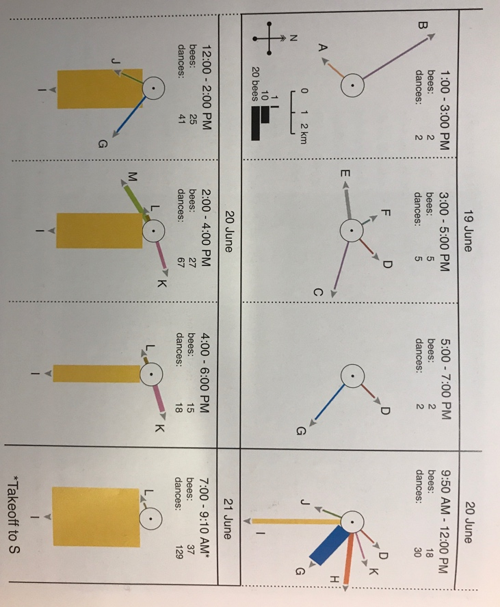
Each vector, labelled by a capital letter, represents the direction and distance of a nesting location from the swarm cluster. The thickness of the vector arrow denotes how many bees are dancing in support of that candidate. Nest G was found first, initially having substantial support, but, it is eventually eventually rejected. Nest I quickly grew to have the greatest backing, until it won through a unanimous election on June 21st. Although its size fluctuates, its proportional support grows. This reflects the mechanism of rest-and-retire and exponential support growth.
Democracy in the honeybee swarm is utilized as a tool that mathematically and logically elects the best nesting location. However, honeybees are not always under ideal conditions, and natural variation in their environment can change the circumstances of each swarm, forcing them to prioritize survival over complete accuracy in their group decision. Time is the biggest constraint, as bee swarms must elect a nest with enough time to prepare for winter, and therefore, the order of the nesting site discovery can affect the end result.
Although the workers gorged themselves with honey, they are not able to withstand the harsh conditions and cold climate. At most, the swarm has enough stored energy to last two weeks. To conserve energy for the construction of the hive, most decisions are made within a few hours or several days, so there is not enough time for a scout to visit every candidate. The honeybees address this issue by replacing the requirement of a unanimous decision with a quorum - a threshold of support that must be met for the entire colony to accept the nesting site. Only a certain number of scouts need to agree rather than the whole group, so accuracy is sacrificed for speed. The shorter the time period, the lower the requirement. An inferior nesting site could be found early enough for its slower growth rate of support to reach this threshold before the optimum candidate.
Another drawback arises if two equally desirable candidates are found at the same time. In one swarm mentioned by Seeley, two sites had equal support for two days, until an unknown event caused the symmetry to slightly erode. This slight difference allowed a candidate to eventually garner unanimous support by the third day. However, the swarm was forced to wait another full day due to rainy weather, so this debate delayed the bees by four days, costing them precious time and resources.
A later swarm was not as fortunate, and the dispute between two nesting sites caused the democratic debate to end in failure. With no decisive lead and time running short, the swarm took flight and “sought to divide itself. The one half wanted to fly to the northwest, the other to the [southwest]. Apparently, each group of scouting bees wanted to abduct the swarm to the nesting place of its own choice.” The two groups struggled for half an hour, surging in each direction before returning to the original site. During this aerial dispute, the queen was lost, and the swarm slowly dissolved as the workers returned to the original hive. The following diagram illustrates this scenario.
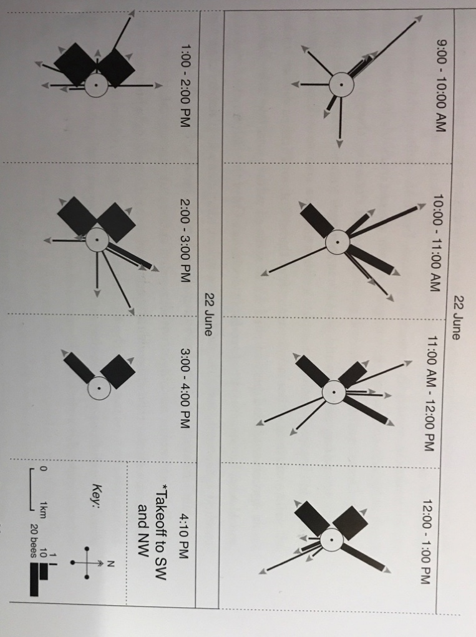
The Northwest(NW) and Southwest(SW) candidates have roughly the same support during the observation period except for the initial fluctuation of candidate exploration. All other candidates eventually disappear until only NW and SW remain. When the swarm takes off at 4:10 PM, it is still divided between those two options. A slight unbalancing of the equilibrium could have allowed the exponential growth rates to produce a victor, but time ran out before this could happen. This is a rare case where compounded environmental challenges overwhelmed the powerful democratic mechanisms of the swarm.
A large part of their success can be attributed to their voting method. Each candidate is given a score through dance circuits, with higher repetitions representing greater preference. There is also an upper limit for this scoring process as honeybees are unable to dance indefinitely, limited by energy and daylight. The exponential growth rate of the most preferred candidate, given enough time, will always result in its victory. This has the same effect as selecting the site with the greatest average score. Lastly, bees do not score candidates that they did not examine, so those situations can be counted as blank ballots. At some point during the election, scouts will consolidate into factions that each advertise their own site. This matches a method known as range voting, with its vote counting computations replaced by a biological process. Researcher Warren Smith ran simulations under conditions similar to the honeybee swarm and compared several different methods, listing their probability of correctly electing the best candidate.
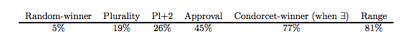
Range voting is clearly the best projected technique with the highest chance of electing the objectively best nesting site. There is still a discrepancy in this simulated eighty-one percent, and the observed ninety percent success rate in nature. Previously discussed facts can explain this. Scouts are experienced foragers and will have an inherently higher probability of choosing correctly. They can only vote with complete honesty, and the best candidate has an advantage of exponential growth in support. These conditions improve the success rate from the simulations to what is recorded from nature.
Furthermore, the main weakness of range voting is mitigated by the nature of honeybees. If a strongly opinionated minority decides to rank their candidate the highest possible score, and give a zero to everybody else, they may be able to steal the election. However, since all honeybees have shared preferences and a unitary goal, there can never be a minority. Even if a small group of scouts came back fervently advertising their site, it would be their honest evaluation of a favorable site, and other bees that examine this nesting location would judge it the same way. Amongst a group of individuals with no conflicts of interests, range voting is among the most effective methods in reliably electing the best candidate.
The honeybee’s voting process is optimized to the extent that it exceeds computer simulations, with its only remaining flaw stemming from the limitations of time and resources. Although their inherent character strongly opposes that of humans, it is important to recognize the power of group wisdom in optimizing the success rate of decision making. Democracy in a swarm of bees combines their relatively simple intellects into a near-perfect tool for survival; democracy utilized correctly in a group of humans could wield their combined intelligence to tackle challenges that are impossible for even the brightest individual.

Works Cited

Couzin, I. D., et al. “Uninformed Individuals Promote Democratic Consensus in Animal Groups.” Science, vol. 334, no. 6062, 16 Dec. 2011, pp. 1578–1580., science.sciencemag.org/content/334/6062/1578.full. Accessed 20 Sept. 2017.

Conradt, Larissa, and Christian List. “Group decisions in humans and animals: a survey.” Philosophical Transactions of the Royal Society B: Biological Sciences, vol. 364, no. 1518, 27 Mar. 2009, pp. 719–742. The Royal Society rstb.royalsocietypublishing.org/content/364/1518/719.short. Accessed 20 Sept. 2017.,

Krause, Jens, et al. “Swarm intelligence in animals and humans.” Cell Press, Jan. 2010, pp. 28–34. Http://Www.sciencedirect.com/, www.sciencedirect.com/science/article/pii/S0169534709002298. Accessed 19 Sept. 2017.

Seeley, Thomas D. Honeybee democracy. Princeton, NJ, Princeton University Press, 2010.

Smith, Warren D. “Ants, Bees, and Computers agree Range Voting is best single-Winner system.” pp. 1–7. Http://Rangevoting.org/, 24 Apr. 2007, rangevoting.org/WarrenSmithPages/homepage/naturebees.pdf. Accessed 19 Sept. 2017.

Seeley, Thomas D. Honeybee democracy. Princeton, NJ, Princeton University Press, (2010): 34-40.
Seeley, 54-57
Seeley, 118
Smith, Warren D. “Ants, Bees, and Computers agree Range Voting is Best Single-Winner system.” (Apr. 2007): 5
Seeley, 118-119
Krause, Jens, et al. “Swarm intelligence in animals and humans.” (Cell Press, Jan. 2010):28–34
Smith, 6
Krause, 28-34
Conradt, Larissa, and Christian List. “Group decisions in humans and animals: a survey.” Philosophical Transactions of the Royal Society B: Biological Sciences, vol. 364, no. 1518. (Mar. 2009): 719–742
Smith, 6
Seeley,141-142
Seeley, 89
Smith, 5
Krause, Jens, et al. “Swarm intelligence in animals and humans.” (Cell Press, Jan. 2010):
Seeley, 83
Smith, 5
Couzin, I. D., et al. “Uninformed Individuals Promote Democratic Consensus in Animal Groups.” Science, vol. 334, no. 6062, 16. (Dec. 2011): 1578–1580

