Black Holes

Miles Andrew Turpin

MATH 89S | Dr. Hubert Bray

Duke University

In 1916, Albert Einstein published his theory of General Relativity which completely changed the way we looked at space. One of the hallmarks of a good theory is that it makes predictions about the world, which we can then go out and test, and affirm—or disprove—the theory. When the periodic table was constructed in 1869 by Russian chemist Dimitri Mendeleev, there were only 56 elements discovered; Mendeleev predicted their inevitable discovery and left spaces in the table for them. Similarly, one of the consequences of Einstein’s theory was that there could exist objects in space whose mass could distort spacetime so much that even light would not be able to escape. 55 years later, Cygnus X-1 was first the first object to be formally identified as a ‘black hole’ (Carroll).

Black holes are regions of space where gravity is so strong that nothing can escape out of the region. The mass of a black hole is thought to be concentrated at an infinitesimally small point called a *singularity*. Whether or not this is the case will be touched upon later in this paper.

Black holes are formed from supernovae events. Stars are first created when gas that is swirling around in the universe finally begins to accumulate enough so that a region of gas begins to condense on itself. This building pressure along with the friction of the gas creates heat, which increases until the gas ignites, creating a star. The outward pressure from the burning of the gas reaches an equilibrium with the attractive pressure of gravity and the star stabilizes at a certain size. Eventually the ‘fuel’ inside the star will run out and there will be nothing to keep the gas from collapsing in on itself, resulting in the implosion we witness as supernovae (Odenwald)**.** Not all stars end up as black holes; for stars up to 10-15 times the mass of our sun, the outer layers will be thrown off and the new core will be a white dwarf or a neutron star (Redd). Neutron stars are also very fascinating celestial objects which form from stars that have undergone supernovae but are not large enough to break the threshold required to form a black hole. They are small objects (only 30 some kilometers in radius) composed mainly of densely packed neutrons. They are so dense that a matchbox containing neutron star material would have a mass of 15 million tons (Odenwald).

Every black hole has an *event horizon* (if the black hole is charged it may have an inner and outer event horizon), a *singularity*, a *photon sphere*, and an *ergosphere*, and sometimes an *accretion disk* which will be explained as we go (Carroll). According to the *no hair theorem*, black holes can be completely described by three measurements: mass, charge, and angular momentum. Some black holes may also have an accretion disk, a ring of matter spiraling around the black hole as it falls in. The friction created by this matter creates intense heat that builds as the matter gains velocity as it approaches the black hole. If the matter generates enough friction and heat, this energy is enough to produce X-rays, which shoot out along the axis of rotation of the black hole (Odenwald). These accretion disks especially occur in binary systems where there is a star orbiting the black hole that contributes matter to the black hole. Quasars, which are some of the brightest objects that we see in the sky, are believed to be supermassive black holes at the centers of galaxies which are emitting these massive amounts of electromagnetic radiation as matter falls into their accretion disks. Pulsars are to neutron stars what quasars are to black holes. Pulsars are interesting in that we only see the beam of radiation emitted as the rapidly rotating neutron star happens to position itself so that the beam can be seen on Earth. The consequence of this is that we see objects in the sky which “blink” regularly as they shine on Earth on the order of milliseconds to seconds, hence the name “pulsar” (pulsating radio star). Because of their incredibly regular rotational periods, certain kinds of pulsars rival atomic clocks in their accuracy (Pranab).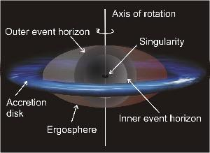

1. Mass: The size of the black hole wholly (no pun intended) depends on its mass. The Schwarzschild radius represents the radius of the event horizon and anything inside this radius can’t escape. All planets or celestial objects have something called escape speed, which is the minimum speed one would have to travel to theoretically completely break away from the planet’s gravitational field (which would happen at an infinite distance away). Escape speed depends only on the mass of the planet and the radius of the planet and is represented by the expression *escapeSpeed = sqrt( 2*G*M / R )* where G is the gravitational constant. The escape speed for Earth is 11.2 kilometers per second, and rockets must attain this speed to leave Earth’s orbit. The escape speed of a black hole is greater than the speed of light. This fact can lead to the misconception that the black hole slows down light until it comes to a stop and falls into the black hole --rather gravity is curvature of spacetime. Objects travelling in a straight line in a gravitational field experience deflection from that straight line proportional to the strength of the gravitational field. Light is observed as being distorted around massive celestial objects as this deflection causes light to deviate from its original trajectory. The gravitational field in a black hole is so strong that light directed from any which direction will inevitably be deflected into the black hole.Calculating the Schwarzschild radius is rather straightforward from the escape speed definition. Given some mass M, and setting escape speed equal to the speed of light (300,000,000 meters per second), one gets the Schwarzschild radius for that given mass. A black hole with the mass of the sun would have Schwarzschild radius of 3 kilometers! Although only stars bigger than our sun can create black holes, black holes are thought to exist in all sizes (Odenwald).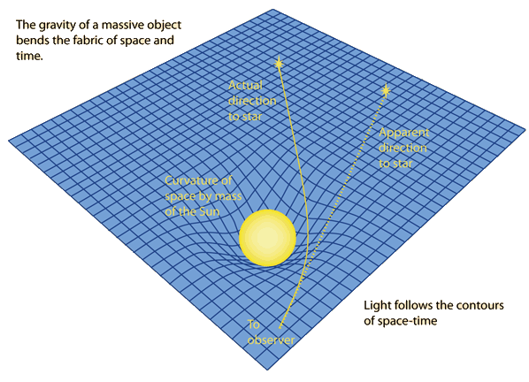
2. Rotation: Stars generally tend to rotate. When a star undergoes a supernova and reforms to create a new core (whether that be a dwarf star, a neutron, or a black hole), the angular momentum must be conserved (this is very similar to linear momentum for those of you unfamiliar with physics) yet the radius of the new core is drastically smaller. The result is that the neutron star or black hole begins rotating at an incredibly fast rate, up to an order of a thousand times per second (Odenwald). The increase in angular speed in this scenario is analogous to a figure skater pulling in their arms to spin faster. Because of this rotation, Relativity predicted that just outside the black hole, that is the event horizon, spacetime would be getting dragged by the rotation of the black hole. On November 6, 1997 the NASA Rossi XRT satellite detected this dragging of spacetime by three spinning black holes GRS 1915+105, J1655-40 and Cygnus X-1 (Odenwald). This region of spacetime being dragged around is called the *ergosphere*, and the effect is called the *Lenz-Thirring effect*. Note in the illustration that the ergosphere bulges out at the “equator” of the black hole. Theoretically all matter drags the spacetime around it, yet these effects are significant around a black hole due to the strength of the gravitational field (Carroll). GRS 1915+105 and Cygnus X-1 are particularly interesting as they are both X-ray binary star systems. An X-ray binary star system is one where a black hole or neutron star and a normal star orbit each other. The normal star is a *donor* and contributes mass to the *accretor* (the black hole or neutron star). When this mass is transferred, the change in gravitational potential energy is released as X-rays (Greiner). The release of radiation accompanied with the infall of matter into the black hole actually works against the increased inflow of matter, thus the rate at which matter enters stabilizes at what is called the *Eddington Accretion Rate*. A solar mass black hole will consume the mass of our sun approximately every 100 million years (Odenwald). One other consequence of a rotating black hole is that the singularity actually forms a ring in the plane of rotation as opposed to a point.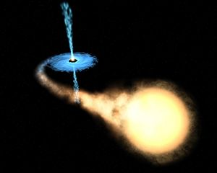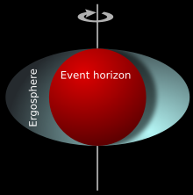
3. Charge: Reissner-Nordström Geometry describes the geometry around a charged but non-rotating black hole. The consequence of having a charged black hole is that there will be two horizons—an inner and an outer. The outer horizon is what we’d typically think of as the event horizon, but then at the center is a repulsive singularity, and neutrally charged objects will remain on the inner horizon. However, this is mostly theoretical—it is highly unlikely that a black hole would acquire enough of a single charge for this to occur, as the charges tend to cancel out as matter comes into the black hole (Odenwald).

The issue of the singularity raises important questions in physics. Relativity predicts that as you approach the center of the black hole, the strength of the gravitational field becomes infinite—what we would call a *singularity* (Carroll). So is there actually a singularity at the center of a black hole? This would seem to cause issues in physics, as infinity seems to be unrealizable in our universe. Mathematics would predict that as water flows down a drain, the velocity of the water at the center of the vortex created should go to infinity, yet clearly this is not the case. Generally when physics theories produce infinity as a result, it is a sign that the theory must be modified. For this reason, many physicists think relativity needs to be reworked to avoid the singularity.

Another point of interest about black holes is that they can be used to “travel into the future”. A consequence of relativity is that of time-dilation—time moves slower as gravitational fields get stronger. So, as you get closer and closer to a black hole, time will move slower and slower for you, relative to someone considerably further from the black hole. If you went away from the black hole after spending considerable time near it, you would find yourself significantly younger than an observer who stayed afar. Also because of this time dilation effect, black holes will not actually look like black holes until you get close. From our perspective, the matter from the collapsing star will take an infinite amount of time to reach the singularity.

There are many misconceptions about black holes, and certain speculations that some people assume to be true (e.g. you can use black holes to travel to other worlds, or to other parts in the universe). One assumption people make is that black holes suck in everything around them. However, if the sun was replaced with a black hole of the same mass, nothing would happen (Odenwald). The strength of a gravitational field is proportional to the mass of the given object and inversely proportional to the distance from the center of the object. Therefore, you would experience the same force of gravity being 3,000,000 miles away from a star or a black hole of the same mass. That being said, there is a difference between the two; the gravitational field of a planet or star increases as you get closer, maxes out at the surface of the object, and then actually decreases linearly as you go inside of the planet (this result comes from the fact that as you get closer to the center of a planet, part of the mass of the planet is behind you and is working against the rest of the planet. At the center of the planet, gravity is zero, as the forces from every which direction sum to 0). Because of the density of black holes, you are able (theoretically) to get so close to the point where the gravitational field reaches incredible strengths. So just keep your distance and you should be fine during any interstellar travel. Also, black holes may not be eternal. Hawking proposed in 1975 the idea of Hawking Radiation. In empty space, there are spontaneous particle and antiparticle separations that appear and re-annihilate each other all the time. This happens around black holes, except if one member goes in the black hole and another escapes, the black hole could be said to be losing mass. If this indeed occurs, it happens on an incredibly slow timescale, so black holes are functionally eternal (Odenwald). 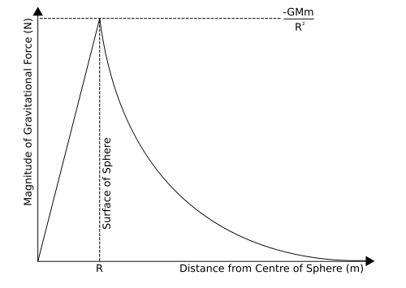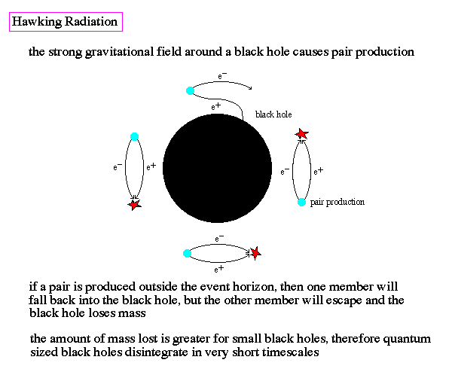

Black holes remain to be in the public eye, as this year gravitational waves were for the first time detected by LIGO after two massive black holes collided, and the energy released in that collision was enough to send sizable ripples through spacetime. However, the debate around black holes today circulates around what is called the *Information Paradox*. The idea is that because of the no hair theorem, it would appear that regardless of what goes into a black hole, the only information we can glean is the mass, angular momentum, and charge. This is an issue for physicists, because we want to be able to gain insight about how objects may have been formed by getting information on them. If the information stayed in there forever it wouldn’t be an issue, it just wouldn’t be accessible. However, Hawking Radiation seems to say that black holes do eventually evaporate, but Hawking Radiation in the form of spontaneously appearing particles does not seem to carry any information about what went into the black hole, thus there seems to be a loss of physical information after it goes into the black hole (Hawking). This contradicts the principle of unitarity in quantum mechanics which deals with conservation of probability. One proposed solution that our mathematics seems to suggest is that as matter goes into a black hole, there is a correlated increase in surface area of the black hole, thus, the information is in a sense projected across the surface of the black hole (Odenwald). The idea that the information in a three dimensional object can be represented by a two dimensional surface that bounds it seems counterintuitive, as we’d imagine that two dimensional objects could never inherently store as much information as three dimensional ones, yet our mathematics is pointing for that to be the case.

Works Referenced

Odenwald, Sten F. Back to the Astronomy Café: More Questions and Answers about the Cosmos from "Ask the Astronomer" Boulder, CO: Westview, 2003. Print.

Carroll, Sean M. Spacetime and Geometry: An Introduction to General Relativity. San Francisco: Addison Wesley, 2004. Print.

Greiner, J. GRS 1915+105. 28 Nov 2001. <https://arxiv.org/abs/astro-ph/0111540>

Redd, Nola Taylor. "Black Holes: Facts." Space.com. N.p., n.d. Web. 03 Oct. 2016.

Pranab, Ghosh. Rotation and accretion powered pulsars. World Scientific, 2007

Hawking, S. W. "Does God Play Dice?"